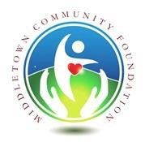

2022
MIDDLETOWN COMMUNITY FOUNDATION SCHOLARSHIP APPLICATION

Name

Address

City Zip Code

Phone ( ) Email

High School:

College or University Attending in Summer or Fall 2022:

Major Field of Study:

REFERENCE: Please list the name, address and telephone number of a teacher, employer, or other person (non-relative) who knows you, can describe the public service you rendered to date, and would be available to answer questions regarding your commitment to public service.

Name Telephone Number ( )

Email Address:

REQUIREMENTS:

Please attach an essay of up to 500 words that describes the public service you have rendered to date, why you chose this form of public service, and how this public service has changed your life. Essays must be typed in 12-point font. Hand-written essays will not be accepted.

Completed applications must be postmarked by MAY 6, 2022 to be considered for the 2022 scholarship program. Mail completed applications to:

MIDDLETOWN COMMUNITY FOUNDATION
P.O. BOX 1128 LANGHORNE, PA 19047

