Stormwater Management: Perspectives from Four Pennsylvania Municipalities. This video from the DEP Secretary in 2017 explains why municipalities in PA embark on the same journey to manage storm water. The first 4-minutes is recommended. | https://www.youtube.com/watch?v=jcMxD5cAoQw
Mill Creek (Otter Creek) Watershed Assessment, Nov. 2002. This 114-page study notes that the Mill Creek Watershed is impaired over 20 years ago. | https://bucksccd.visualsuits.com/wp-content/uploads/2021/05/millcreekfinal.rpt1_.pdf
How to retrofit stormwater basins to reduce water volume and pollution. 3-page brochure. Basin Information. | https://pecpa.org/wp-content/uploads/2022/04/Water-Resources-Basin-Retrofits.pdf
How to retrofit stormwater basins to reduce water volume and pollution. Full 46-page report. Page 15 is Outreach Section and lists the issues that residents want addressed. | http://water.rutgers.edu/Projects/GreenInfrastructureChampions/Talks_2020/8_Handouts/8_PEC_BasinRetrofitGuide.pdf
Neighborly Natural Landscaping in Residential Areas. This 8-page document has an informative Fact & Myth section about naturalized basins. | https://extension.psu.edu/neighborly-natural-landscaping-in-residential-areas
Sediment Reduction Initiative Stormwater Basin Retrofit. This is the naturalization project and the seed mix list is on page 9. This is the public bid document that was implemented. | Meadow Planting Drawing
Basin Naturalization Project Flyer. Middletown’s one-page summary of the project, useful for a complete and brief summary. | Basin Naturalization Project Fact Sheet
Showy Northeast Native Wildflower Mix. Contains the showiest native forbs common in the Northeast. Excellent for wildlife food and shelter, including pollinators. These three plants represent 35% of the seed mix: in order, Tall White Beardtongue, Purple Coneflower, Partridge Pea. The meadow plantings will take several years to be in full bloom. | 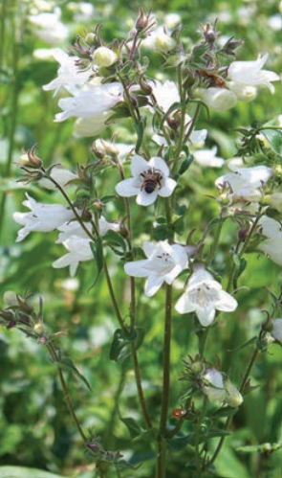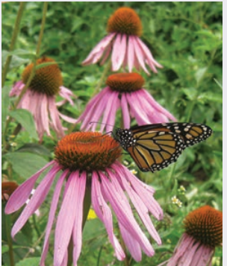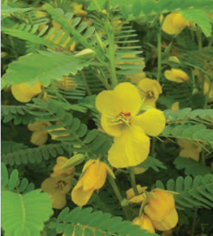  https://www.ernstseed.com/wp-content/uploads/2022/03/Ernst-Seeds_2022-2023-Catalog_Reduced-Size.pdf
Pennsylvania Soils Drainage Classes by County. See page 30 for the Bucks County Area. | https://extension.psu.edu/programs/nutrient-management/planning-resources/other-planning-resources/pennsylvania-county-drainage-class-tables

